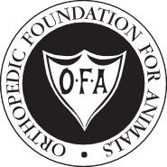
Orthopedic Foundation for Animals

Office Use Only
Office Use Only
APPL RAD
CK
2300 E Nifong Blvd, Columbia, MO 65201-3806 Phone: (573) 442-0418; Fax: (573)875-5073
www.offa.org
A Not-For-Profit Organization

Application for Hip/Elbow Dysplasia Database
This Application: □ Hip Dysplasia only Elbow Dysplasia only □ Hip and Elbow Dysplasia together
□
Registered name: |  |  |  | AKC Registration Number: |  |  |  |  |  |  |  |  |  |  | Other registry name: Other registry #:
Breed: |  | Sex: |  | Date of Birth (MM/DD/YY): |  |  |  |  |  |  |  |  |  |  | Date radiograph taken (MM/DD/YY):
ID Number (if any):  Tattoo  Microchip |  |  |  | Registration number of sire: |  |  |  |  |  |  |  |  |  |  | Registration number of dam:
Owner name: |  |  | 🢃 VETERINARIAN INFORMATION 🢃 | Examining veterinarian’s name or veterinary hospital:
Co-Owner name: |  |  |  | Mailing Address:
Mailing address: |  |  |  | City: |  |  |  |  |  |  |  |  |  |  | State: | Zip/postal code:
City: | State: | Zip/postal code: |  | Phone: |  |  |  |  |  |  |  |  |  |  | FAX #:
Phone: |  |  |  | Veterinarian Email:
Owner e-mail. Please print one letter/symbol per cell.

If there are questions regarding this appliction contact:
Vet:
by Phone
by Email OR
Owner:
by Phone
by Email

I hereby certify that the image submitted is of the animal described on this application and that neither the pelvic nor the elbow conformation have been surgically altered. I understand that the image submitted will be retained by the OFA. I understand that the image is submitted for a consensus evaluation based on the independent, professional judgment of consulting board-certified veterinary radiologists, and I hereby release the OFA from any and all liability resulting from the consensus evaluation. I understand the OFA will release normal hip and/or elbow results for dogs over 24 months to the public, and by submitting this application I agree the OFA may do so. Abnormal hip and/or elbow results will not be released to the public unless the initials of a registered owner appear in the authorization box below. Normal hip results are defined as consensus evaluations of Excellent, Good, or Fair. Abnormal hip results are defined as consensus evaluations of Mild, Moderate, or Severe. For the purpose of determining whether or not the results will be released to the public, consensus hip evaluations of Borderline are considered abnormal. Normal elbow results are defined as a consensus evaluation of Normal. All other elbow consensus evaluations are considered abnormal.
□
□
□
□
□
□
Signature of owner or authorized representative
Authorization to Release Abnormal Results
I hereby authorize the OFA to release the results of its evaluation of the animal described on this application to the public if the results are abnormal (initials of registered owner).

Veterinary Information
This animal was restrained using:
❑ Physical Restraint Only
❑ Chemical Restraint
❑ Anesthesia (type: )  Tranquilizer (type: )  Other (type: )
❑ I DID verify the tattoo/microchip information on this dog  I DID NOT verify the tattoo/microchip information on this dog
Only dogs with Verified Permanent Identification (VPI) will have their results transmitted to the AKC for inclusion in their registration and pedigree documents
Veterinarian Signature

Fees
Animals Over 24 Months
- Hip dysplasia database only $35.00
- Hips plus elbows (together) $40.00
- Elbow dysplasia database only $35.00
- Litter of 3 or more submitted together $90.00
Kennel Rate—Individuals submitted as a group, owned/co-owned by same person.
- Minimum of 5 individuals $15 per study

Animals Under 24 Months
- Preliminary hip evaluation $30.00
- Preliminary elbow evaluation $30.00
- Preliminary hips plus elbows (together) $35.00
- Litter of 3 or more submitted together $60.00
(see page 2 for information regarding release of prelim results)
Consultation
- Other radiographic studies $30.00

See instructions on page 2
Payments can be made by check, money order (U.S. funds drawn on a U.S. bank), cash, Visa, or Mastercard, payable to the Orthopedic Foundation for Animals.
❑

Party Responsible for Payment is:  Veterinarian  Owner/Co-Owner  Other

Card Type:
Visa  MasterCard

Card Number
Cardholder Name
Exp. (MM|YY) CVV

2/24/14

Instructions for Taking Images for OFA Dysplasia Evaluations

Images should be permanently identified with:
- 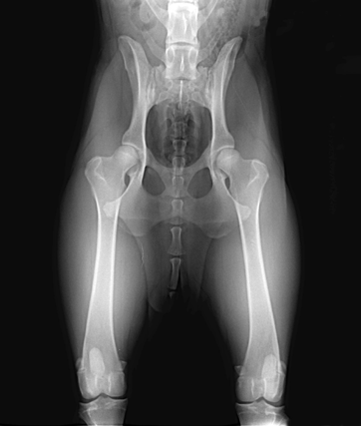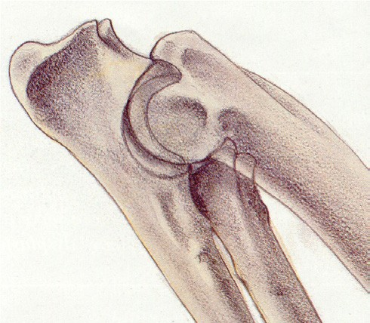Registered name and/or number
- Name of veterinarian or hospital making the film
- Date image taken
- Pelvic evaluation are based on the standard VD view with good pelvic definition, pelvis not tilted and femurs extended and parallel
- Elbow evaluations are based on the extreme flexed medial to lateral view

OFA Database
The dysplasia control database of the OFA is a voluntary program established to evaluate images and to identify films showing no evidence of dysplasia or other orthopedic prob- lems. All images submitted that are of acceptable diagnostic quality will be reviewed by qualified veterinary radiologists and a consensus report will be returned to the owner of record and referring veterinarian. Only animals that are 24 months of age or older to the day at the time of radiography, with no radio- graphic evidence of dysplasia, will be assigned a breed OFA number. The OFA does offer a consultation service for those under 24 months of age.

Age Requirement
Only dogs that are 24 months of age, to the day, or older at the time of radiography can qualify for an OFA hip number. In gen- eral hip joint status of younger dogs will be evaluated but only a consultation report will be issued. For toy and small breeds interested in the Legg-Calve-Perthes Database the animal has to be 12 months of age or older. The dog’s registration certifi- cate or copy of this information should be available at the time of radiography.

OFA Policy Regarding Release Of Preliminary Re- sults (Animals Under 24 Months)
In an effort to encourage open sharing of health test results, the OFA will post preliminary results if:
- The animal is at least 12 months at the time of radiography
- The animal must be permanently identified via microchip or tattoo
- The owner initials the authorization block to release all results (including abnormal results) when the application is initially submitted

Restraint
Obtaining proper position often requires chemical restraint. The OFA recommends chemical restraint to the point of mus- cular relaxation. The type of agent used—sedative, tranquiliz- er, or general anesthesia—is best determined by the attending veterinarian.

Positioning
Dorsal recumbency with the rear legs extended and parallel to each other is the preferred positioning. This standard ven- trodorsal view is the basis for evaluation of hip joint status with respect to hip dysplasia. Care should be exercised to be sure the pelvis is not tilted. Elbow joints are evaluated in the fully flexed medial to lateral position.

Image Size
For large and giant breeds of dogs, 14” x 17” film size is rec- ommended. Smaller sizes can be used for smaller breeds if the area between the sacrum and the stifles can be included.

Image Identification
Permanent identification of the image is required to be eligible for OFA evaluation. Lead letters, an I.D. camera, or radio opaque tapes can be used to identify film. Digital images should have embedded text.
- with the hospital or Veterinarian’s name, date taken, regis- tered name and/or registration number or
- with the veterinarian’s unique case number.
  - In this latter case (b), the image must be accompanied by a signed note from the veterinarian referring to such film by its unique case number and stating the information previously required in (a) above.
  - If the above required information is illegible or missing, the OFA cannot accept the film for evaluation purposes. The images should be labeled right or left side for hip studies and right or left elbow for elbow studies.

Exposure
Good contrast is desirable (high mAs, low kVp). Grid techniques are recommended for all large dogs.

Radiation Safety
Proper collimation and protection of attendants is the respon- sibility of the veterinarian. Gonadal shielding is recommended for male dogs.

Hormonal Effect
Some female dogs show subluxation when radiographed around an estrus cycle which is not apparent when re-radio- graphed in anestrus. The OFA recommends radiographing 3-4 weeks before or after a heat period or 3-4 weeks after weaning a litter of pups.

Application for OFA Film Evaluation
The owner or agent must complete and sign the OFA applica- tion form. This information is best obtained directly from the dog’s certificate of registration and it is recommended that a copy of the registration be included with the submission. Application forms are available on request from the OFA and from the OFA website at www.offa.org. The image, signed form, and service fee should be mailed together to the Or- thopedic Foundation for Animals at the address on the front of this form.

